NAME :Ashutosh Rode ROLL NO : 72 DIV : B

Q1] Write a program to Plot the correlation plot on dataset and visualize giving an overview of relationships among data on iris data.

import pandas as pd import seaborn as sns

import matplotlib.pyplot as plt # Load the Iris dataset

url = "https://archive.ics.uci.edu/ml/machine-learning-databases/iris/iris.data" column_names = ["sepal_length", "sepal_width", "petal_length", "petal_width", "class"] iris_data = pd.read_csv(url, names=column_names)

# Calculate the correlation matrix correlation_matrix = iris_data.corr()

# Create a heatmap to visualize the correlations plt.figure(figsize=(8, 6))

sns.heatmap(correlation_matrix, annot=True, cmap="coolwarm", linewidths=0.5) plt.title("Correlation Plot of Iris Dataset")

plt.show()

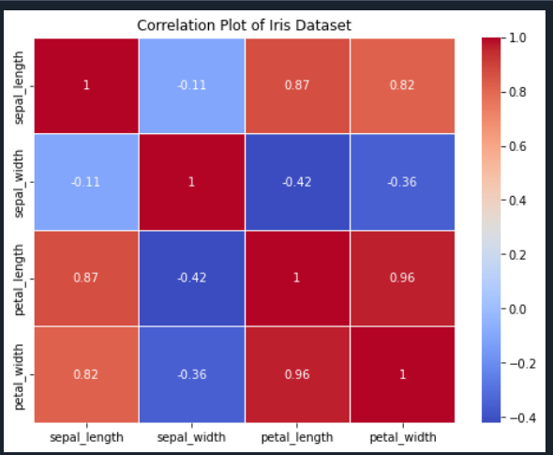

NAME :Ashutosh Rode ROLL NO : 72 DIV : B

Q2] Write a program to implement linear regression algorithm to create and evaluate a model on a given dataset.

import numpy as np

from sklearn.model_selection import train_test_split from sklearn.linear_model import LinearRegression

from sklearn.metrics import mean_squared_error, r2_score # Sample dataset (replace this with your own dataset)

# X represents the independent variable, and y represents the dependent variable. X = np.array([1, 2, 3, 4, 5, 6, 7, 8, 9, 10]).reshape(-1, 1)

y = np.array([2, 4, 5, 4, 5, 6, 8, 8, 10, 10])

# Split the data into training and testing sets

X_train, X_test, y_train, y_test = train_test_split(X, y, test_size=0.2, random_state=42) # Create a linear regression model

model = LinearRegression()

# Train the model on the training data model.fit(X_train, y_train)

# Make predictions on the test data y_pred = model.predict(X_test)

# Evaluate the model

mse = mean_squared_error(y_test, y_pred) r2 = r2_score(y_test, y_pred)

# Print the model's coefficients and evaluation metrics print("Coefficients:", model.coef_)

print("Intercept:", model.intercept_) print("Mean Squared Error:", mse) print("R-squared:", r2)

NAME :Ashutosh Rode ROLL NO : 72 DIV : B

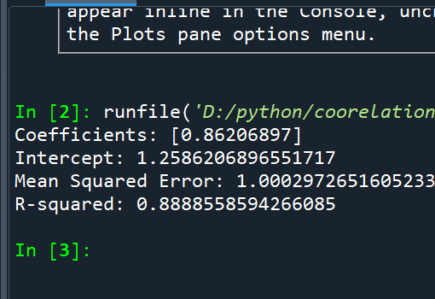

Q3] Write a program to classify the given dataset using logistic regression and evaluate the model.

import numpy as np

import matplotlib.pyplot as plt

from sklearn.model_selection import train_test_split from sklearn.linear_model import LogisticRegression

from sklearn.metrics import accuracy_score, confusion_matrix, classification_report # Generating a synthetic dataset for binary classification

np.random.seed(0)

X = np.random.rand(100, 2)

y = (X[:, 0] + X[:, 1] > 1).astype(int)

# Split the data into training and testing sets

X_train, X_test, y_train, y_test = train_test_split(X, y, test_size=0.2, random_state=42) # Create a logistic regression model

model = LogisticRegression()

# Train the model on the training data model.fit(X_train, y_train)

# Make predictions on the test data y_pred = model.predict(X_test)

NAME :Ashutosh Rode ROLL NO : 72 DIV : B

# Evaluate the model

accuracy = accuracy_score(y_test, y_pred) conf_matrix = confusion_matrix(y_test, y_pred) class_report = classification_report(y_test, y_pred) # Print the evaluation metrics

print("Accuracy:", accuracy) print("Confusion Matrix:\n", conf_matrix) print("Classification Report:\n", class_report)

# Visualize the decision boundary (works for 2D data only) if X.shape[1] == 2:

plt.scatter(X[:, 0], X[:, 1], c=y, cmap=plt.cm.Spectral) h = .02 # step size in the mesh

x_min, x_max = X[:, 0].min() - 1, X[:, 0].max() + 1

y_min, y_max = X[:, 1].min() - 1, X[:, 1].max() + 1

xx, yy = np.meshgrid(np.arange(x_min, x_max, h), np.arange(y_min, y_max, h)) Z = model.predict(np.c_[xx.ravel(), yy.ravel()])

Z = Z.reshape(xx.shape)

plt.contourf(xx, yy, Z, cmap=plt.cm.Spectral, alpha=0.8) plt.xlabel("Feature 1")

plt.ylabel("Feature 2") plt.title("Decision Boundary") plt.show()

NAME :Ashutosh Rode ROLL NO : 72 DIV : B

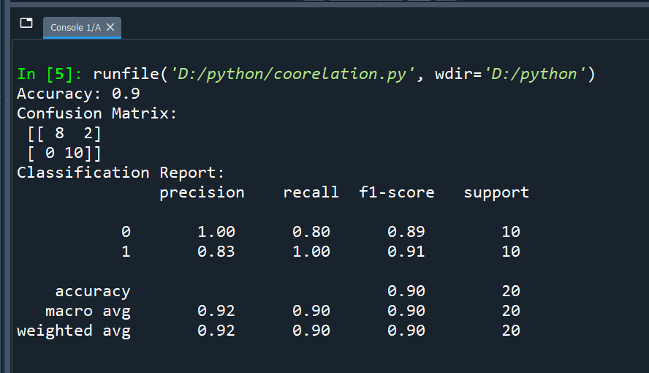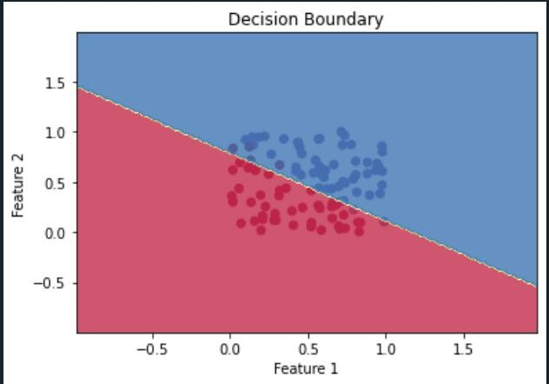

Q4] Write a program to implement support vector machine algorithm import numpy as np

from sklearn import datasets

from sklearn.model_selection import train_test_split from sklearn.svm import SVC

from sklearn.metrics import accuracy_score, confusion_matrix, classification_report # Load a sample dataset (you can replace this with your own data)

# We'll use the built-in Iris dataset for this example. iris = datasets.load_iris()

X = iris.data

NAME :Ashutosh Rode ROLL NO : 72 DIV : B

y = iris.target

# For binary classification, let's consider only two classes (0 and 1). X = X[y != 2]

y = y[y != 2]

# Split the data into training and testing sets

X_train, X_test, y_train, y_test = train_test_split(X, y, test_size=0.2, random_state=42) # Create an SVM classifier

model = SVC(kernel='linear')

# Train the SVM model on the training data model.fit(X_train, y_train)

# Make predictions on the test data y_pred = model.predict(X_test)

# Evaluate the model

accuracy = accuracy_score(y_test, y_pred) conf_matrix = confusion_matrix(y_test, y_pred) class_report = classification_report(y_test, y_pred) # Print the evaluation metrics

print("Accuracy:", accuracy) print("Confusion Matrix:\n", conf_matrix) print("Classification Report:\n", class_report)

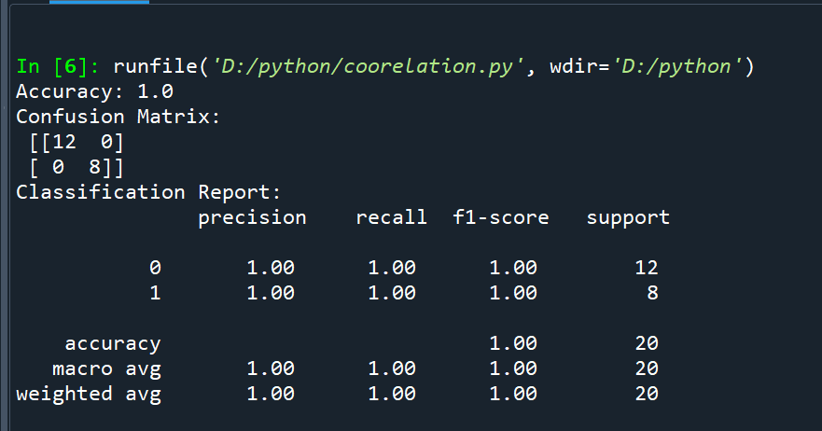

NAME :Ashutosh Rode ROLL NO : 72 DIV : B

Q5] Write a program to implement Decision Tree model on the given dataset import numpy as np

from sklearn import datasets

from sklearn.model_selection import train_test_split from sklearn.tree import DecisionTreeClassifier

from sklearn.metrics import accuracy_score, confusion_matrix, classification_report # Load a sample dataset (you can replace this with your own data)

# We'll use the built-in Iris dataset for this example. iris = datasets.load_iris()

X = iris.data y = iris.target

# Split the data into training and testing sets

X_train, X_test, y_train, y_test = train_test_split(X, y, test_size=0.2, random_state=42) # Create a Decision Tree classifier

model = DecisionTreeClassifier()

# Train the Decision Tree model on the training data model.fit(X_train, y_train)

# Make predictions on the test data y_pred = model.predict(X_test)

# Evaluate the model

accuracy = accuracy_score(y_test, y_pred) conf_matrix = confusion_matrix(y_test, y_pred) class_report = classification_report(y_test, y_pred) # Print the evaluation metrics

print("Accuracy:", accuracy) print("Confusion Matrix:\n", conf_matrix) print("Classification Report:\n", class_report)

NAME :Ashutosh Rode ROLL NO : 72 DIV : B

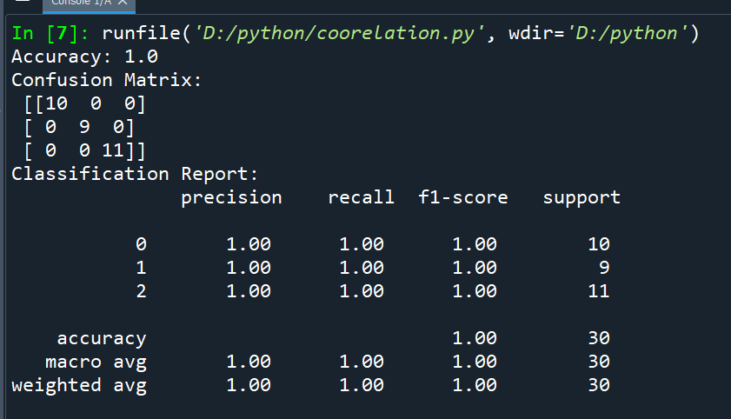

Q6] Write a program to implement Bayesian classification on given dataset. import numpy as np

from sklearn import datasets

from sklearn.model_selection import train_test_split from sklearn.naive_bayes import GaussianNB

from sklearn.metrics import accuracy_score, confusion_matrix, classification_report # Load a sample dataset (you can replace this with your own data)

# We'll use the built-in Iris dataset for this example. iris = datasets.load_iris()

X = iris.data y = iris.target

# Split the data into training and testing sets

X_train, X_test, y_train, y_test = train_test_split(X, y, test_size=0.2, random_state=42) # Create a Naive Bayes classifier (Gaussian Naive Bayes)

model = GaussianNB()

# Train the Naive Bayes model on the training data model.fit(X_train, y_train)

# Make predictions on the test data y_pred = model.predict(X_test)

NAME :Ashutosh Rode ROLL NO : 72 DIV : B

# Evaluate the model

accuracy = accuracy_score(y_test, y_pred) conf_matrix = confusion_matrix(y_test, y_pred) class_report = classification_report(y_test, y_pred) # Print the evaluation metrics

print("Accuracy:", accuracy)

print("Confusion Matrix:\n", conf_matrix)

print("Classification Report:\n", class_report)

